Castellanos Kenpo Karate

Nunchaku seminar
When: Saturday, March 16, 2019
Time: 1pm-3pm
Cost: Basic students-$60(with nunchaku purchase)
$40 (without purchase)
Leadership- $50 (with nunchaku purchase)
$30 (without purchase)
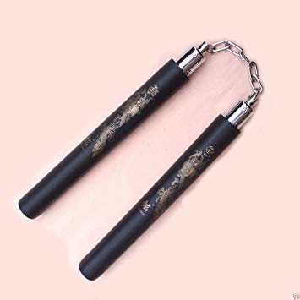
*Sign up on front table. Payment due March 14th*

